Path: Engineering -> CGL Proposal Dashboard
Screen Code: S0554

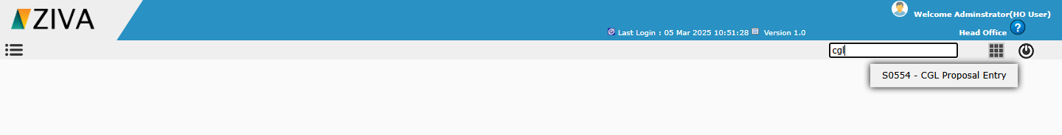
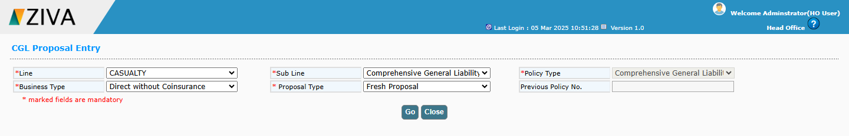

After selecting the sub Line and policy type details, on clicking Go button, remaining fields to capture the proposal details will be displayed.

In Location details, click on Add new Location icon, user can able to create a new Location.
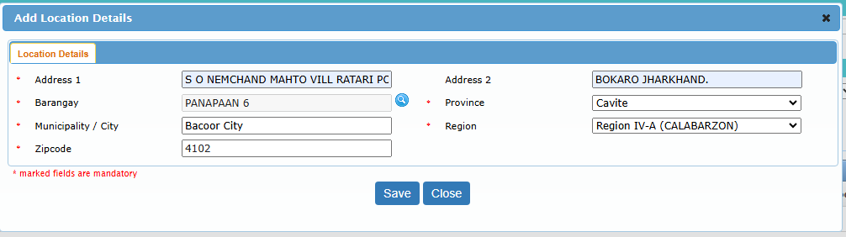
On clicking Save button, system add the Location details. In the Location details on clicking Premises icon, Then enter the Floor Sq, Location Rate for the respective location.
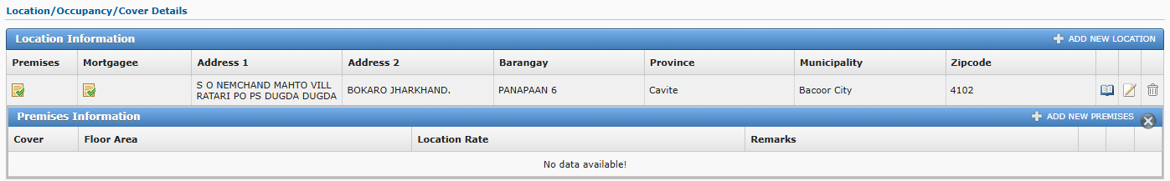

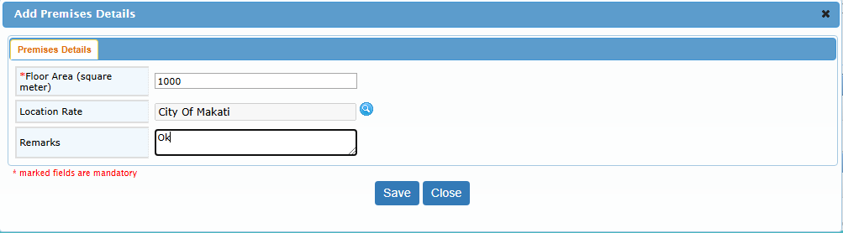
Basic cover, Rate and Premium automatically calculate based on the user entered input in Premises details tab.

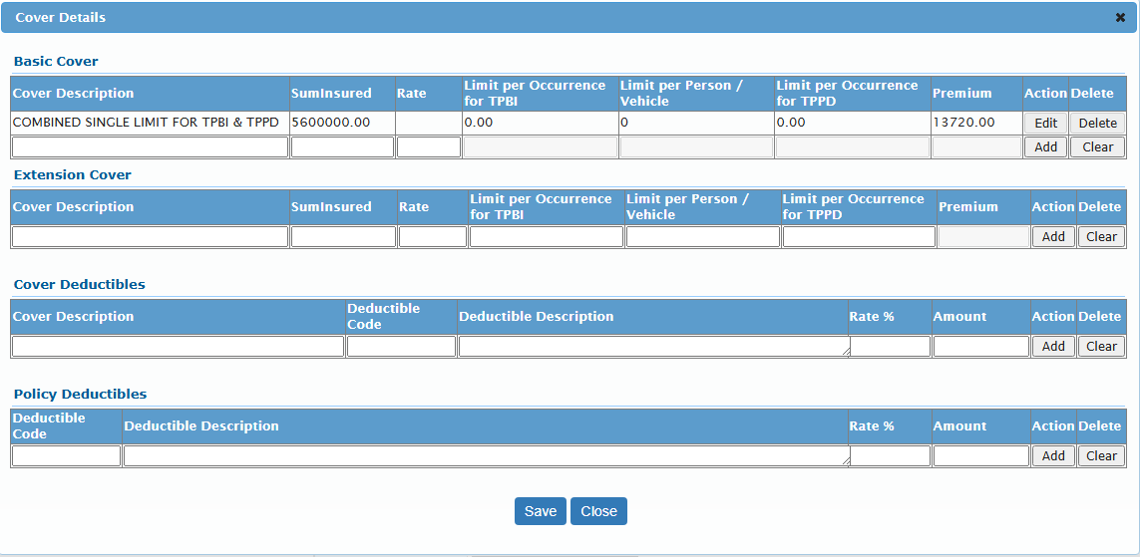
User can able to add the Mortgagee details for the location by clicking the mortgagee icon.

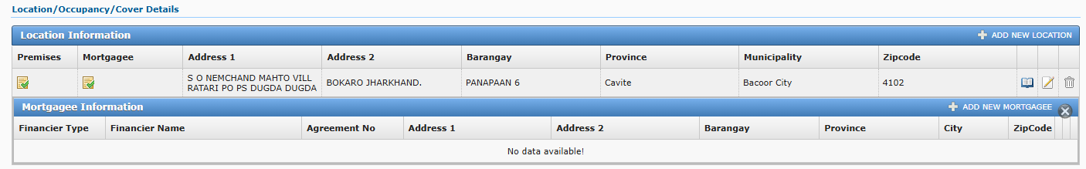

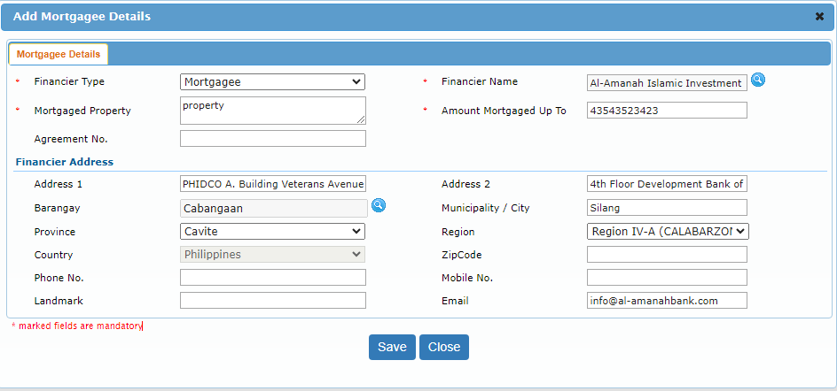

After entering all the details and click on calculate premium user can generate a RFQ number.

After entering all the details and click on calculate premium user can generate a Quote.

After generate a Quote , Generate Policy Button Enable.

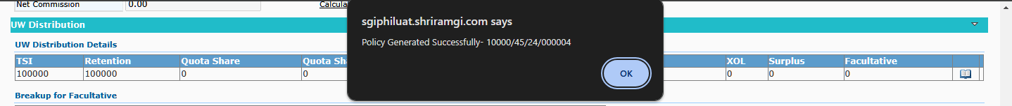

After click a Generate Policy Button, Policy will be Generated Successful.

